Creelman Exam Questions: Human Biology ATAR Course Units 3 and 4, 2019

10.
The following list relates to characteristics of the nervous system.

(2014:1.04)

The next three questions refer to the diagram shown below.
Chapter 2: Nervous system

- effectors are usually skeletal muscles
- involves parasympathetic and sympathetic nerves
- carries information from the CNS to effectors
- carries information from the brain to the spinal cord
- nerve pathway has no ganglion
- usually controls involuntary actions

The characteristics that describe the somatic division of the peripheral nervous system correctly are

- i, ii, iii.
- iv, v, vi.
- i, iii, v.

A

B C D

E

13.

(2015:1.14)

- ii, iii, vi.

11.

(2014:1.12)
The part of the brain responsible for the maintenance of posture and balance is
- H.
- G.

Which of the following comparisons of the nervous and endocrine systems is correct?

 | Nervous system | Endocrine system
(a) | slower transmission of message | faster transmission of message
(b) | electrochemical message | chemical message
(c) | message is general, targeting a large number of cells | message can be specific or general, targeting a small or large number of tissues
(d) | response continues after stimulus stops | response stops when stimulus stops
- C.
- A.

14. (2015:1.15)
Two of the structures labelled on the diagram provide protection for the brain. They are
- D and F.
- D and B.
- H andF.
- Hand B.

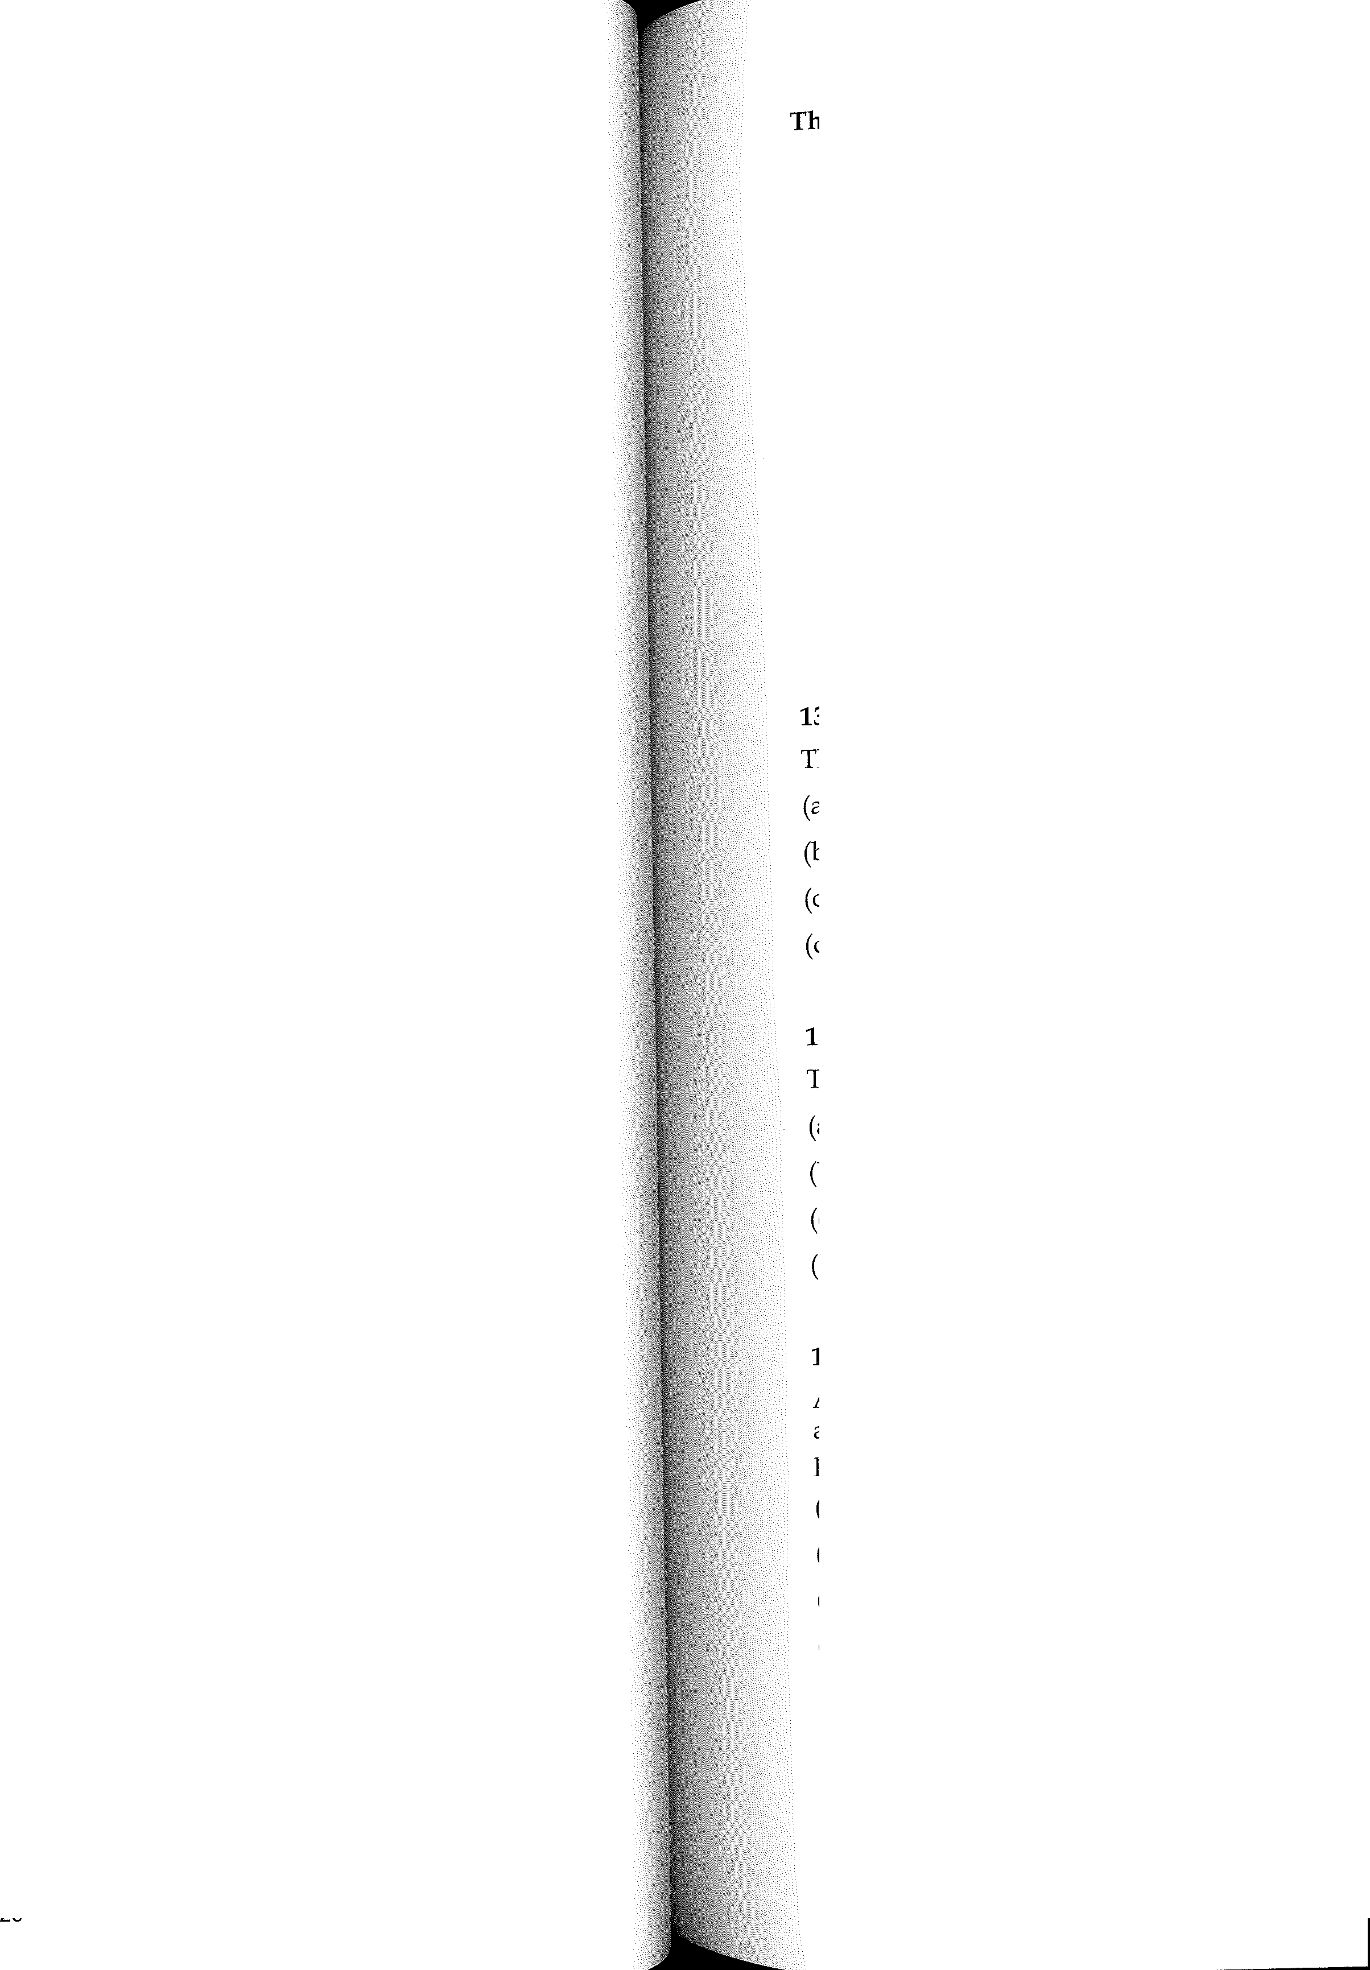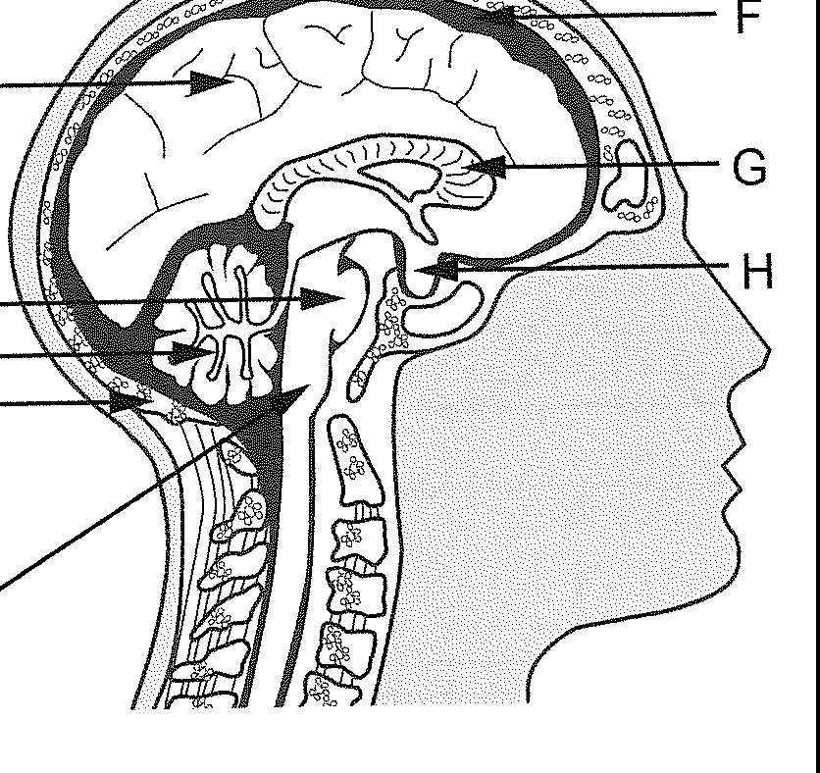12.
Which of the following is not a fight-or-flight response?
- increased sweat production
- constriction of the pupil of the eye
- relaxation of the walls of the urinary bladder
- decreased saliva secretion
(2014:1.18)

15. (2015:1.16)
An MRI scan of a person's brain revealed they had a tumour growing on the structure shown as E. This tumour was causing dysfunction of structure E. Which of the following would be a possible symptom the person would be experiencing?
- loss of some short- and long-term memory
- changes to appetite and thirst
- constant, unexplained sneezing
- difficulty in walking and jumping

Chapter 2: Nervous system

be next two questions refer to the information and diagram shown below.

Divisions of the peripheral nervous system
t

lndicates nervous transmission toward the central nervous system Indicates nervous transmission away from the central nervous system
t

Division A
I \
From skin From
and muscles internal organs
Division B

To smooth muscles and heart
I \

To skeletal muscles

I \
X y

21.
Division B is the
- afferent division.
- efferent division.
- sympathetic division.
- parasympathetic division.
(2016:1.14)

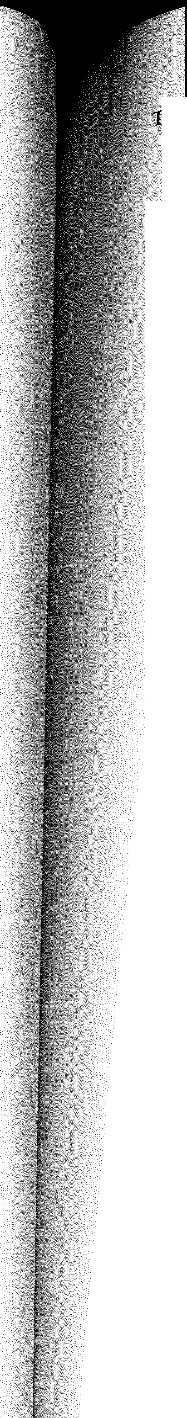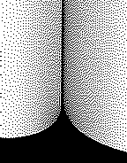

22. (2016:1.15)
X and Y represent divisions of the
- autonomic nervous system that usually transmit nerve impulses under involuntary control.
- somatic nervous system that usually transmit nerve impulses under involuntary control.
- autonomic nervous system that usually transmit nerve impulses under voluntary control.
- somatic nervous system that usually transmit nerve impulses under voluntary control.

23. (2016:1.16)
Schwarm cells
- speed up nerve impulses.
- protect the nerve fibres.
- secrete neurotransmitters.
- produce the myelin sheath.

31

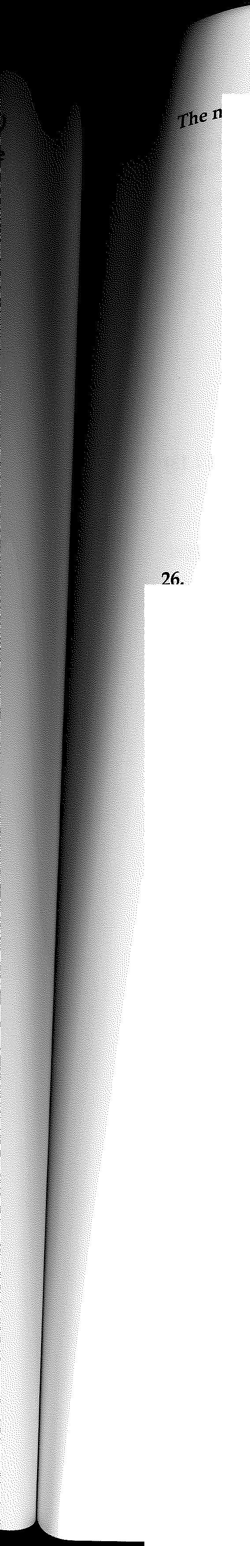

ext two questions refer to the brain diagram shown below.

A Corpus callosum

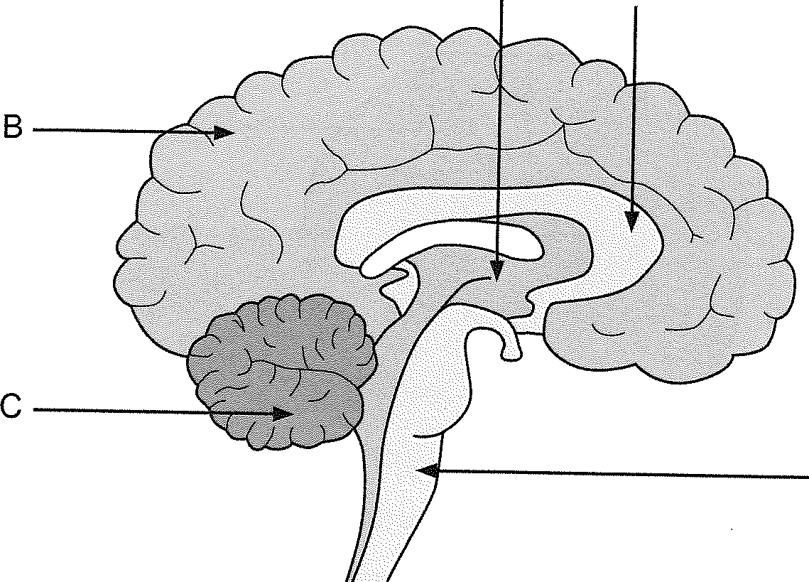

Which part of the brain is responsible for regulating heart rate?
  - A
  - B
  - C
  - D

27.

The corpus callosum relays information to and from the
- cerebral hemispheres.
- hemispheres of the cerebellum.
- hypothalamus.
- spinal cord.

33
Chapter 2: Nervous system

D

(2017:1.01)

(2017:1.02)

Creelman Exam Questions: Human Biology ATAR Course Units 3 and 4, 2019

The next question refers to the diagram shown below.

30.

Chapter 2: Nervous system

(2017:1.20)

Cross-section of the spinal cord
When a nerve impulse reaches the end of a neuron, it is not connected directly to the adjacent neuron. There is a gap between the neurons called a synapse.
The diagram below is a representation of a synapse.

/'

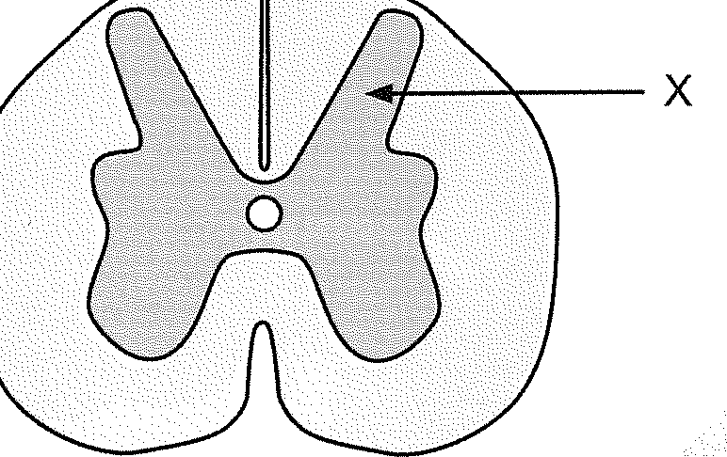
Presynaptic neuron Postsynaptic neuron

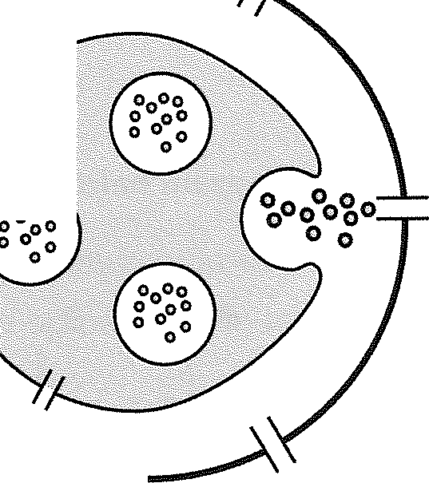28.
Which of the following is correct about the part labelled X?
- grey matter, which is also found on the outer surface of the cerebrum
- white matter, which is also found on the outer surface of the cerebrum
- grey matter, which is also found inside the cerebrum
- white matter, which is also found inside the cerebrum

29.
Which of the following are features of a reflex action?
- spontaneous, involuntary and rapid
- involuntary, stereotyped and require a stimulus
- require a stimulus, voluntary and rapid
- stereotyped, spontaneous and voluntary

34

(2017:1.13)

(2017:1.19)

Which of the following is involved in enabling the nerve impulse to reach the adjacent neuron?
- Mitochondria in the postsynaptic membrane release neurotransmitters into the synapse.
- Vesicles in the presynaptic knob are stimulated by the entry of calcium ions to release neurotransmitters.
- Neurotransmitters diffuse across the synapse and bind to receptors on the presynaptic knob.
- Calcium ions are released by vesicles in the postsynaptic membrane and cross the synapse to release neurotransmitters.

31. (2017:1.23)
Opening a closed door quickly, you are surprised by someone standing on the other side. Your pupils dilate and your heart and breathing rates increase. Which branch of the nervous system has been activated?
- central
- somatic
- parasympathetic
- sympathetic

32. (2017:1.30)
Which of the following is correct in relation to the afferent and efferent nervous systems?
Afferent nervous system | Efferent nervous system
Carries nerve impulses from the receptors to the CNS | Carries nerve impulses from the CNS to the receptors
Carries nerve impulses to the voluntary muscles from the CNS | Carries nerve impulses to the CNS from the voluntary muscles
Carries nerve impulses from the CNS to the receptors | Carries nerve impulses from the receptors to the CNS
Carries nerve impulses from the receptors to the CNS | Carries nerve impulses from the CNS to the voluntary muscles

(a)

(b)

(c)

(d)

35

l_.!. lf,,P.,--

Creelman Exam Questions: Human Biology ATAR Course Units 3 and 4, 2019

The next two questions refer to the diagram below:


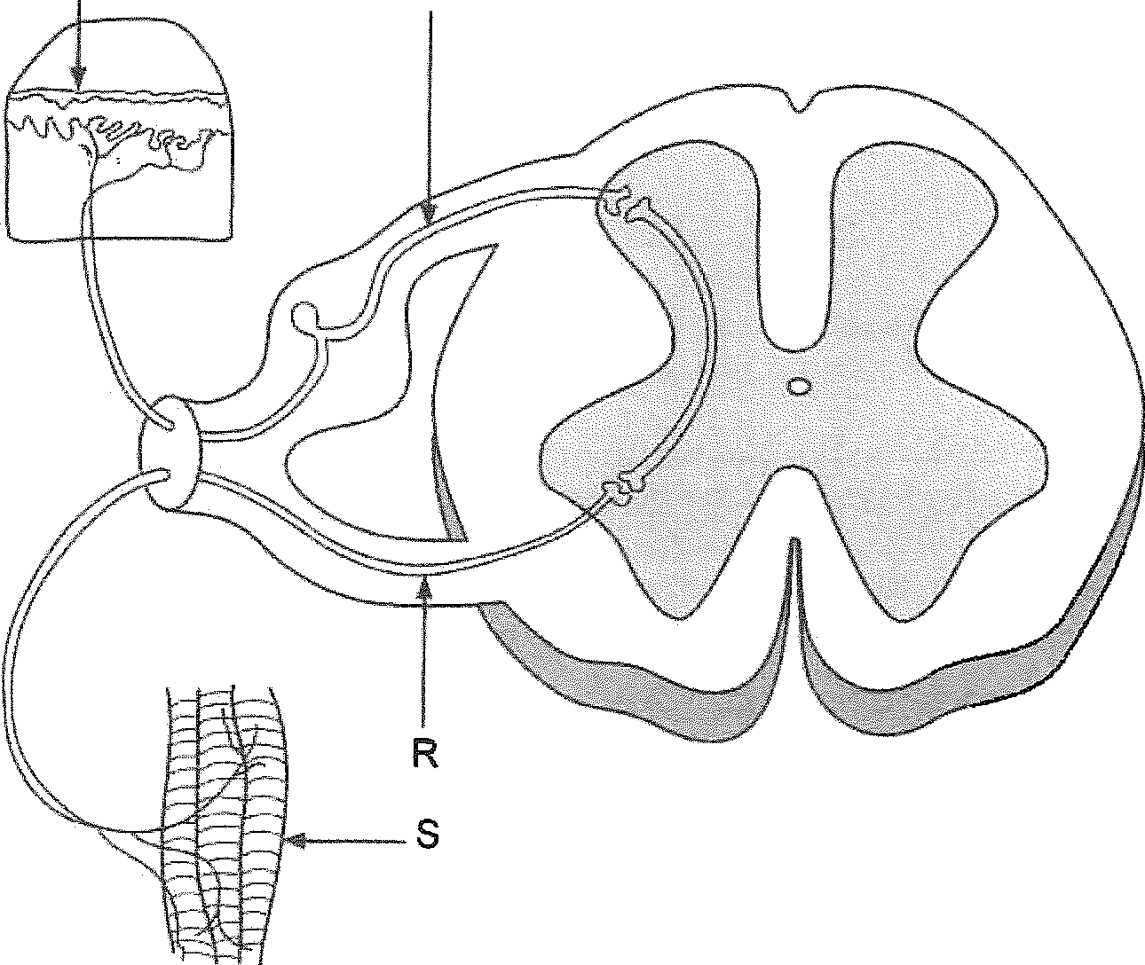
p Q

38.
The structure labelled 'R' can be described as an
  - afferent neuron carrying information away from the spinal cord.
  - afferent neuron carrying information toward the spinal cord.
  - efferent neuron carrying information away from the spinal cord.
  - efferent neuron carrying information toward the spinal cord.

(2018:1.14)

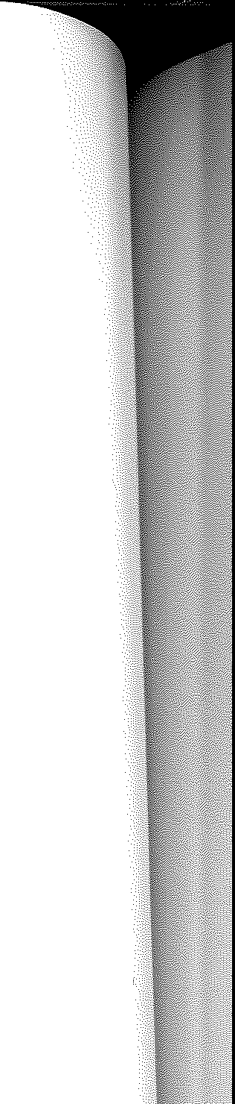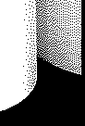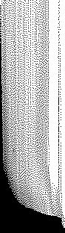

39. (2018:1.15)
Which of the following statements about the detection of a stimulus in the above reflex arc is correct?
- detected by receptors labelled 'P' and transmitted through sensory neurons labelled 'Q'
- detected by receptors labelled 'S' and transmitted through sensory neurons labelled 'R'
- detected by receptors labelled 'S' and transmitted by interneurons labelled 'R'
- detected by sensory neurons labelled 'P' and transmitted through motor neurons labelled

'Q'

38

Creelman Exam Questions: Human Biology ATAR Course Units 3 and 4, 2019

SHORT ANSWER QUESTIONS

43. [13 marks]

(2013:2.39)

(iii) State a reason why reflex arcs are important.

Chapter 2: Nervous system

[1]

Parts (a), (b) and (c) of the question refer to the diagram below, which shows a cross section of the spinal cord and components of a reflex arc.

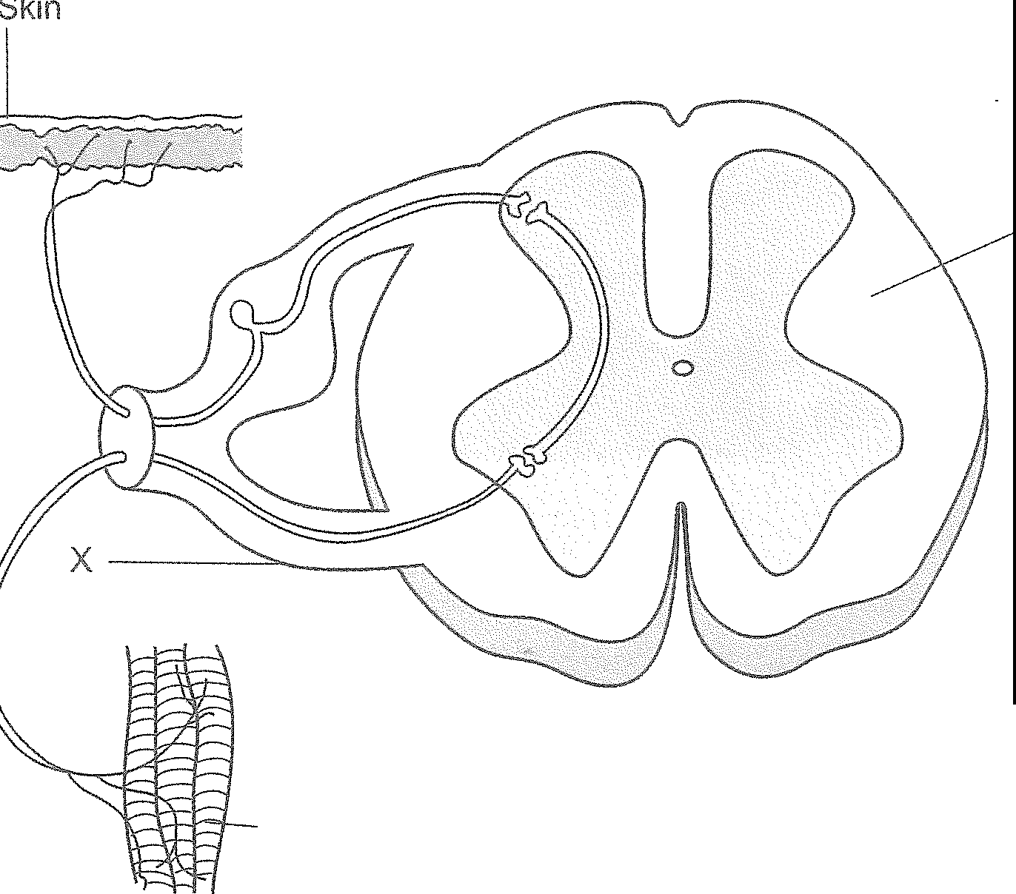(c)
Muscle fibres

y
CIPA is a rare congenital disorder caused by a mutation that prevents the formation of nerve cells which are responsible for transmitting signals of pain.
Would these nerve cells be located closer to the skin or to the muscle fibres, as shown on the diagram? Explain your answer. [2]

Part (d) of the question refers to the following diagram, which shows the organisation and divisions of the nervous system.

nervous

Peripheral nervous system

- (i) Name the type of nerve fibres found in the root labelled 'X'.
Afferent
[1]

(ii) Identify the area shown as 'Y'. [1]
B
Visceral
Autonomic
/
Somatic
Efferent

Sympathetic
Parasympathetic
- The skin and muscle fibres shown in the diagram are associated with a reflex arc.

  - 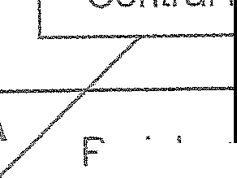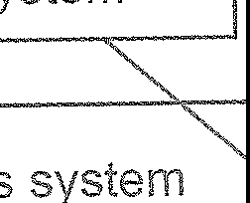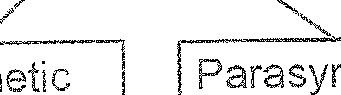Draw an arrow on the diagram to show the direction of a nerve impulse through this reflex arc. [1]

  - State three important functional properties of reflexes. [3]

40

- Using the diagram above, complete the following:

  - On the diagram, draw the head of an arrow on the line labelled 'N to show the direction of impulses between the central and peripheral nervous systems. [1]

  - Where is information communicated to and from by the division shown as 'B' in the diagram? [1]

CONTINUED NEXT PAGE

41

Creelman Exam Questions: Human Biology ATAR Course Units 3 and 4, 2019

[6 marks]

(2014:2.39)

[15 marks]
Chapter 2: Nervous system

(2015:2.32)

Parts (a), (b) and (c) of the question refer to the diagram of a neuron below.

For copyright reasons this image cannot be reproduced here, but may be viewed at http://tle.westone.wa.gov.au/content/file/969144ed-Od3b-fa04-2e88-8b23de2a630c/1/ human_bio_science_3b.zip/ content/ 002_nervous_control/ page_13.htm

- Identify the region of the axon labelled as structure X. [1]

- State one function of the structure labelled Y. [1]

- !he rrows drawn along the axon show the direction of a nervous impulse. The impulse m this neuron would travel via saltatory conduction. Describe how a nervous impulse is propagated along this type of fibre. [4]

44
- Although different diseases, Alzheimer's disease and Parkinson's disease are similar in that they both affect the brain. There are also similarities in the causes and effects of these
diseases. State one such similarity between Alzheimer's disease and Parkinson's disease.
(1)

- The diagram below shows a cross-section of the spinal cord and associated structures. Three different neurons are drawn in a box to the right.
3
2
1

X
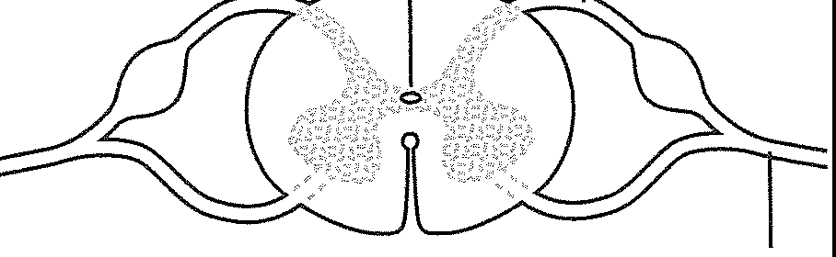y 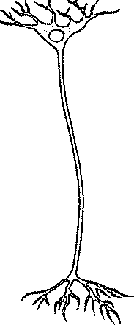 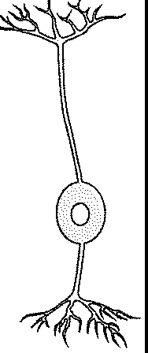 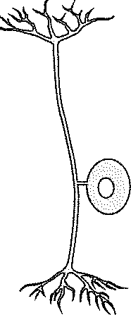
  - Using the numbered labels on the diagrams in the box on the right, indicate which neuron would be located in the region of the spinal cord labelled X. [1]

  - Describe the structure labelled Y in the diagram. [2]

  - Describe the pathway involved in a spinal reflex which brings about a fast, automatic response following stimulation of a pain receptor. [4]

CONTINUED NEXT PAGE
45

Creelman Exam Questions: Human Biology ATAR Course Units 3 and 4, 2019

- Explain how a nervous impulse can travel from one neuron to the next. [3]

- (11 marks]
Chapter 2: Nervous system

(2016:2.32)

The following question refers to the diagram of the skin shown below.

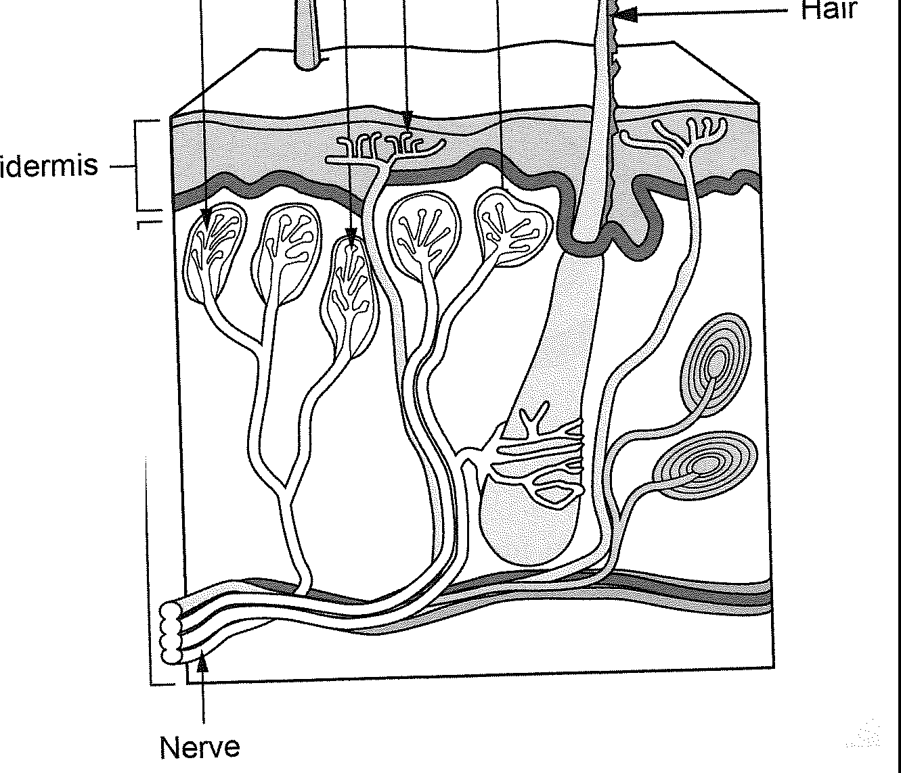w X y z
Dermis

The autonomic and somatic divisions of the peripheral nervous system are both involved in the transmission of nervous impulses from the central nervous system to effectors. However, they differ in both structure and function. Provide two differences between the autonomic and somatic divisions. [4]

Nerve

Identify the type of receptor labelled Y.

[1]

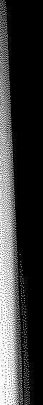

Receptors W, X and Z are all located in the upper region of the dermis, but receptor Y is located in the epidermis. Explain why it is important that receptor Y is located in a different position. [3]
Differences between the divisions of the peripheral nervous system
Autonomic division | Somatic division

- Some of the receptors shown in the diagram are involved in triggering reflexes. Name a type of stimulus that would trigger a reflex. [1]

CONTINUED NEXT PAGE

46 47

Creelman Exam Questions: Human Biology ATAR Course Units 3 and 4, 2019

When a receptor initiates an impulse in a neuron going directly to the spinal cord, it will normally trigger a spinal reflex. The diagram shown below represents a spinal reflex.

A B C

[9 marks]
Parts (a) and (b) refer to the diagram of a neuron shown below.

(a) What type of neuron is shown in the diagram?
Chapter 2: Nervous system

(2017:2.31)

For copyright reasons this image cannot be reproduced in the online version of this document, but may be viewed at link http://pictures-and-images.net/single/67_neuron-diagram-unlabeled­ sensory_9.html

[1]

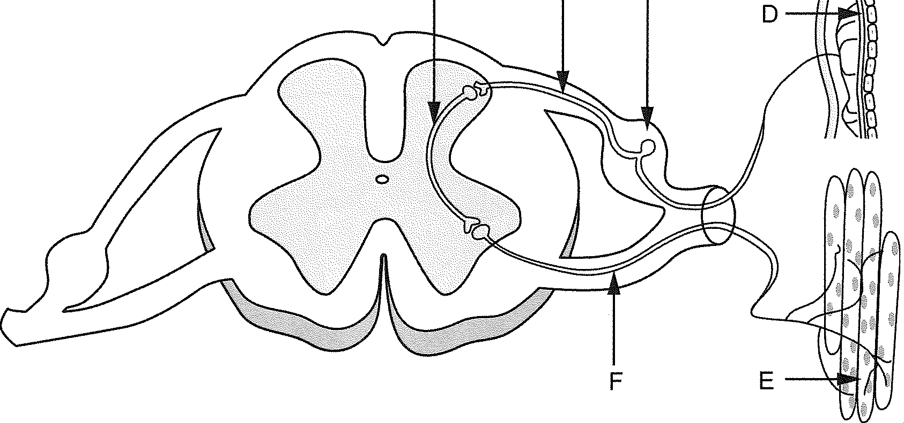
(d) Using the labels in the diagram, identify the following correctly. [2] Afferent neuron: -----------------------------
(b) How does the position of the cell body in other types of neurons differ from the position shown in the diagram? [2]

Interneuron: ------------------------------

- State what is found within the structure labelled C. [1]

- Outline three important functional properties that are associated with all spinal reflexes.
[3]

48

(c)

The nervous and endocrine systems work together to coordinate functions of all body systems. However, they differ in several ways.
Complete the table below to outline three of these differences. [6]
 | Nervous system. | Endocrine system.
Speed of action
Duration of action
Specificity of message

'

49

) [12 marks]
'fhe diagram below shows two motor neurons.

Neuron 1 -' Neuron 2

  - Using the information above, complete the following table.
Chapter 2: Nervous system

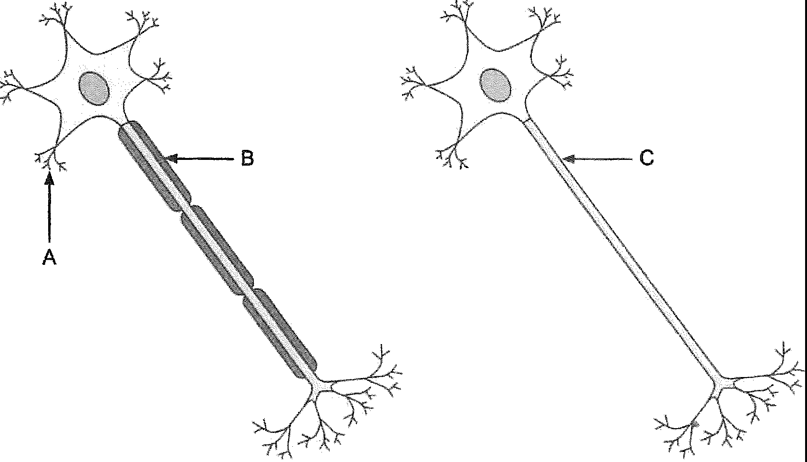
(2018:2.31)

[3]

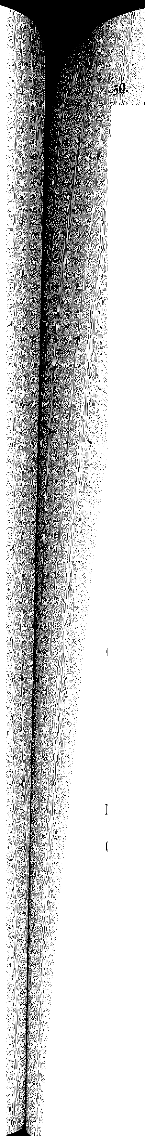
Label | Structure name
A
B
C

  - Describe why nerve transmission would be much faster in Neuron 1 than in Neuron 2.
[2]

Neuron 1 can be found within the somatic division of the nervous system.

  - (i) To what structures in the body would these neurons take messages? [1]

(ii) How does the pathway of a nerve impulse travelling through the neurons of the somatic division differ to that travelling within the autonomic division? [2]

CONTINUED NEXT PAGE

51

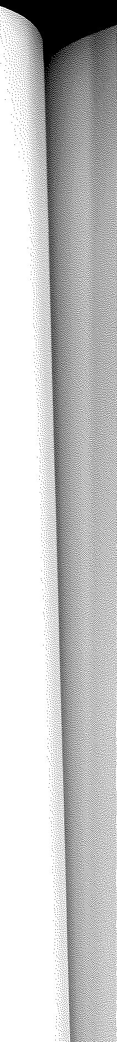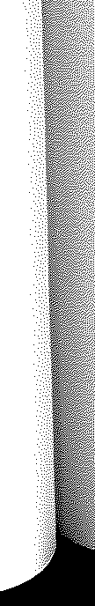

Creelman Exam Questions: Human Biology ATAR Course Units 3 and 4, 2019

Natasha walked into her Human Biology class a few moments late, only to find everyone putting their books and notes away. Her teacher was preparing to hand out a test. Natasha did not know the test was being done and started panicking. The teacher placed the test down on the desks and told the students to begin. Natasha suddenly felt like she was going to vomit.

  - (i) Identify the division of the nervous system activated in Natasha's bodyduring this situation. [1]

    - What was happening in Natasha's body to cause her to feel the way she did? [2]

    - Identify another physiological response that could have been occurring in her body during this situation. [1]

51. [1 mark] (2018:2.34)

(b) State the role of neurotransmitters in the brain and nervous system.

EXTENDED ANSWER QUESTIONS


52. [10 marks] (2017:3.42)
(a) Describe how a nerve impulse is propagated along a myelinated nerve fibre. How does a nerve impulse propagated along an unmyelinated nerve fibre differ?

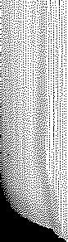
52

